**PH150e/CP117AC Homework#4 Part 1:**

**Assignment Instructions**

**Spring 2019**

You will be assigned one of the following Bay Area ZIP codes. Each zip code includes a BART station, and has a life expectancy that differs from both the county within which it is located and the State of California. This instruction document is for the **94801 Richmond** ZIP code.

**You must follow the steps in this guide to complete HW 4.**

|  |  |  |  |  |
| --- | --- | --- | --- | --- |
| **Zip code #** | l**ocation** | **Avg. Life expectancy (years)** | | |
|  |  | **Zip code** | **County** | **California** |
| **94801** | Richmond, CA | 74 | 81 | 80 |
| **94612** | Oakland (Downtown), CA | 73 | 82 | 80 |
| **94601** | Oakland (Fruitvale), CA | 76 | 82 | 80 |

**94801: Assigned Data**

1. Obesity (area data, source: BRFSS 2014)
2. Free and reduced school lunch (point data, source: NCES CCD 2013-14)

**94612: Assigned Data**

1. Life Expectancy at Birth, Years by Tract (area data, source: CDC and NCHS 2010-15)
2. Assisted Housing Properties, All Project Based Properties (point data, source: HUD 2016)

**94601: Assigned Data**

1. Predominant Race / Ethnicity by Block Group (area data, source: US Census 2010)
2. Federally Qualified Health Centers, (point data, source: POS March 2018)

**PART 1:**

1. Go to <https://engagementnetwork.org/>
2. From the home page, click on **Build a Report**

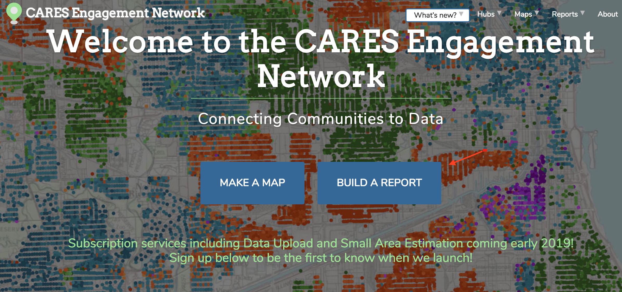

1. Create a Community Health Needs Assessment for your zip code:
   1. Click on **Draw My Area**
   2. In the drop down menu on the left choose **Select ZIP code**.
   3. Enter your assigned ZIP code (ZCTA) in the search bar on the right hand side
   4. Click on your assigned ZIP code in the map area
   5. Click **Reports** on the top right hand corner

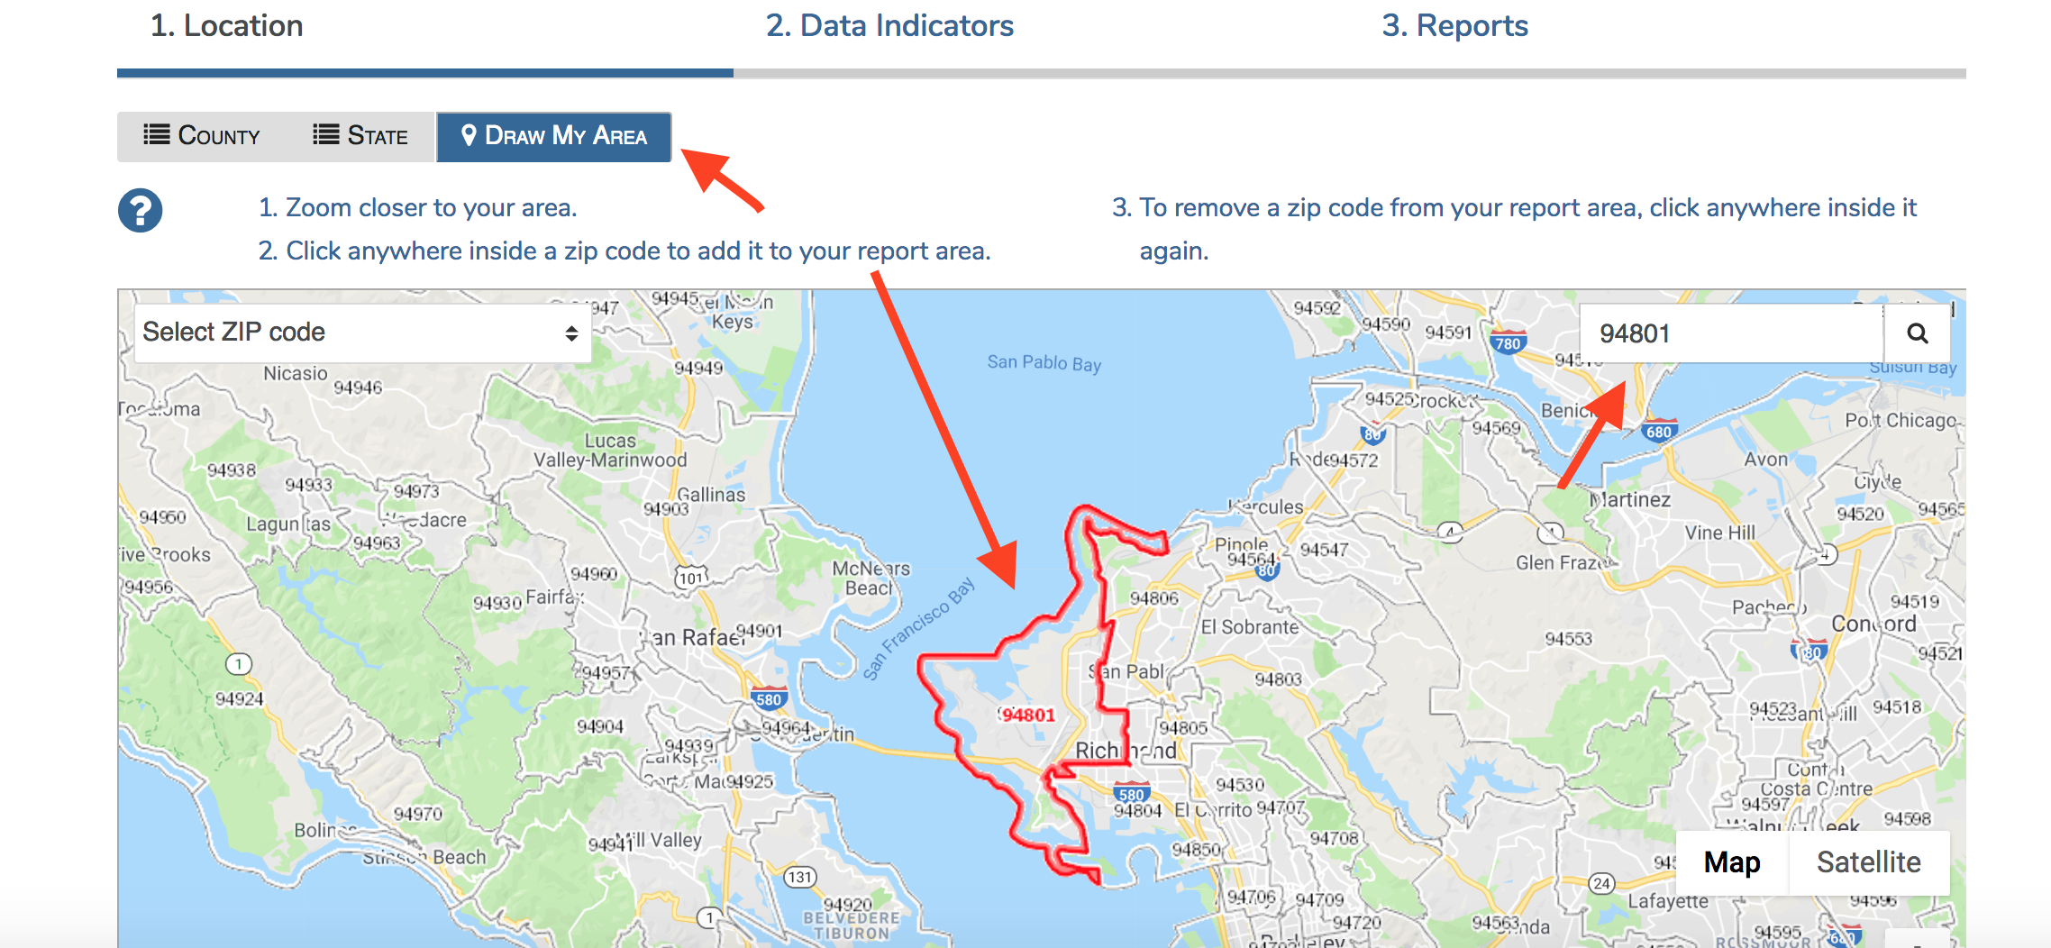

1. Then, click next and Explore the Data Categories and Data Indicators for your ZIP code included in the report. Some of the data will be displayed at the County level, some at the ZIP code level, and some at the Census Tract level.
   1. Check each box for the data indicators (demographics…health outcomes)

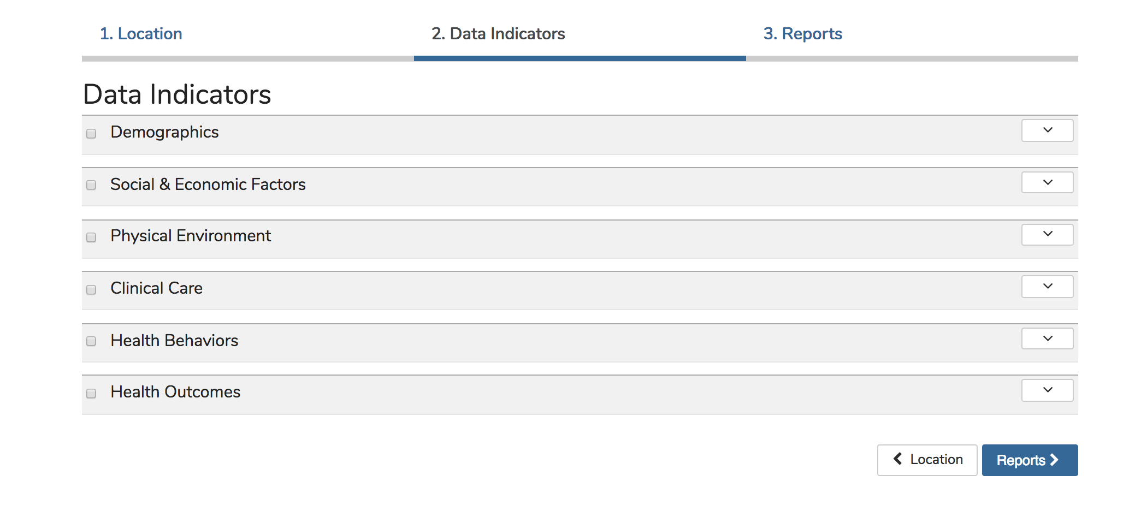

* 1. Please check these specific boxes:

**Demographics**- Total Population Indicator

**Demographics**-Population in Limited English Households

**Social & Economic Factors**: Children Eligible for Free/Reduced Price Lunch

**Social & Economic Factors**: Poverty - Children Below 100% FP

**Physical Environment**: Housing-Substandard housing

**Physical Environment**: Food Environment - SNAP-Authorized Food Stores

**Social & Economic factors**: Population Commuting to Work Over 60 Minutes

**Clinical Care**: Access to Primary Care

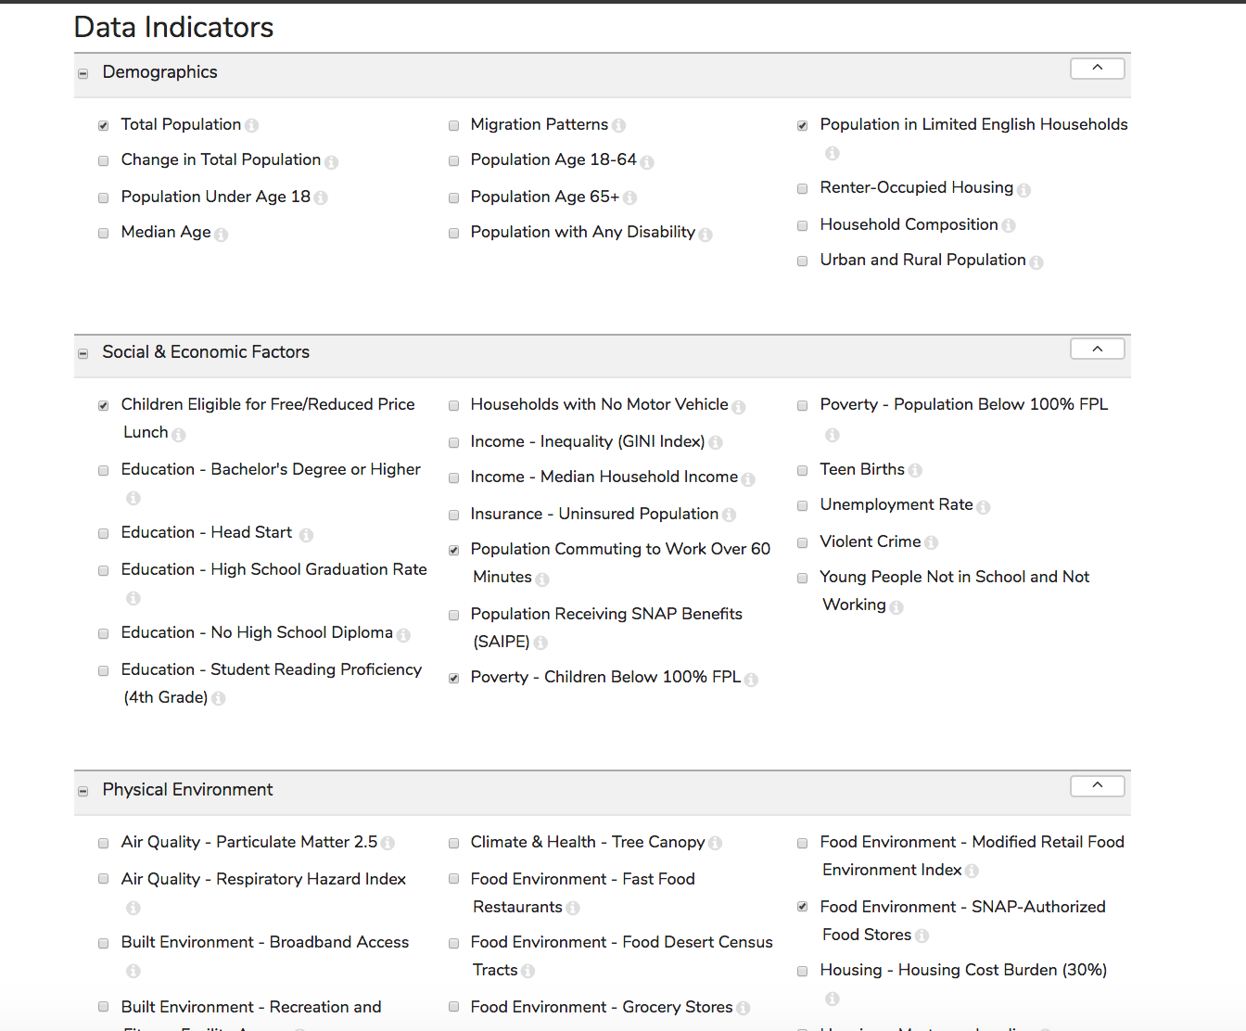

1. Click on reports on the bottom right corner.

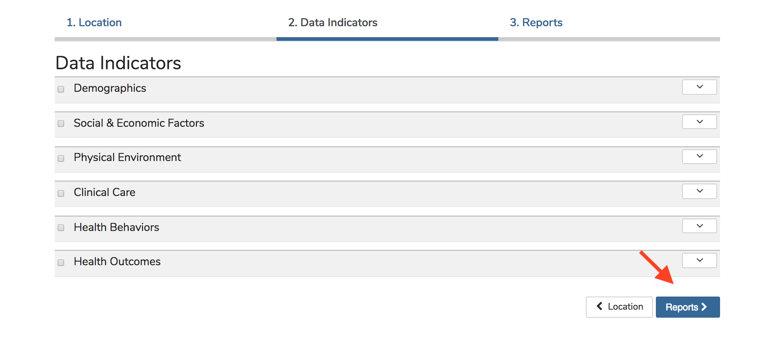

1. Click on Report and answer questions **1-10** on the HW3 assignment worksheet (available on Bcourses) about your ZIP code based on the Health Indicators Report

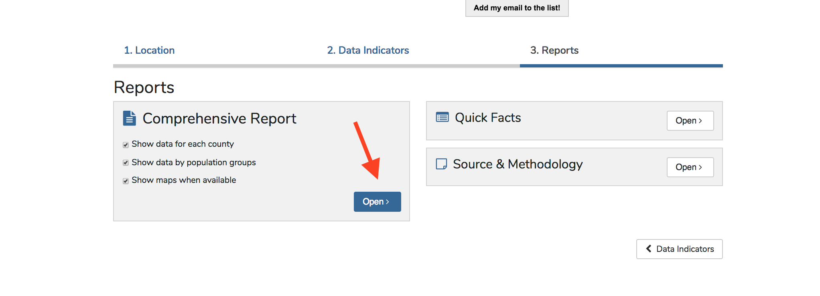

**PART 2:**

1. Go back to the **Maps & Data** page, and click on **Make a Map**

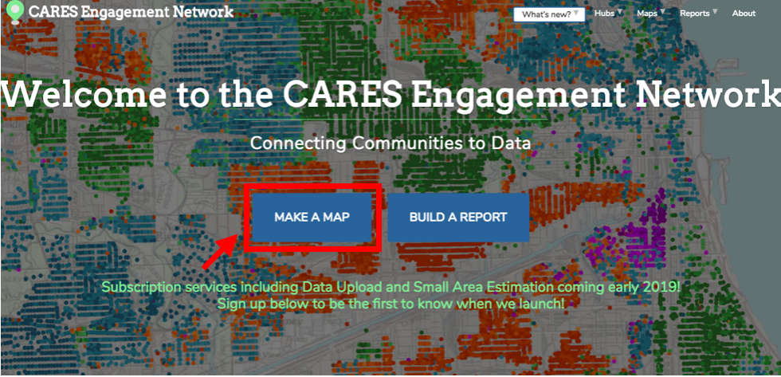

1. A “Search Data” will automatically pop up. Close it for the time being
2. Enter your assigned ZIP code **94801** in the “Enter a location” search bar on the right hand side. The following examples use the 94720 UC Berkeley Zip Code as an example
3. Under the zip code search row, there are the “Map Layers.” Click the right button to display possible map layers and select Place Names. Scroll down and select Water as well.

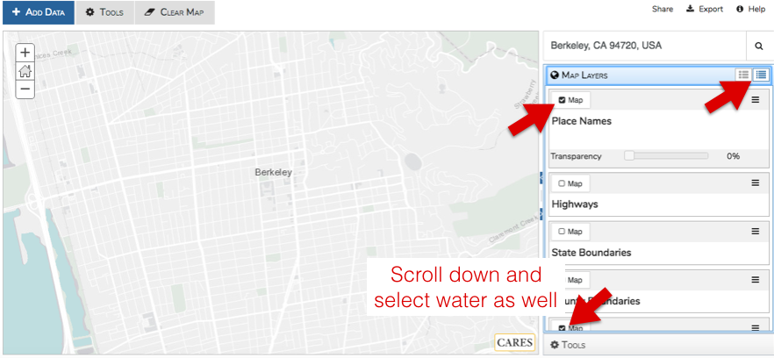

1. Click “Add Data” in the top left corner. Search “Zip Codes” and select ZIP Code Tabulation Area (ZCTA) Boundaries (GBD), TIGER 2018, and Add to Map. 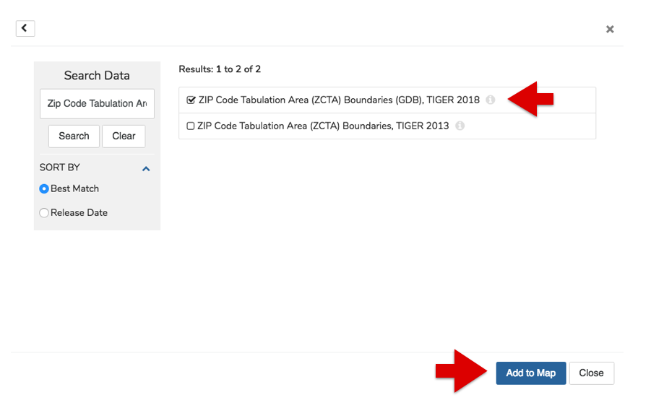
2. Go to Map Layers and select “Label” under Zip Code.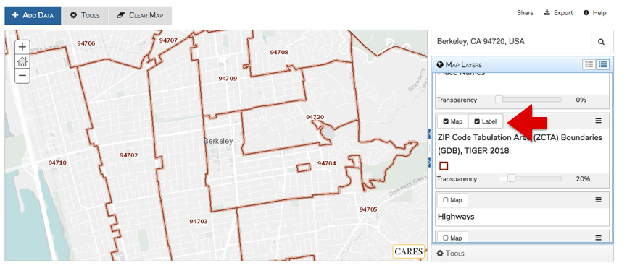
3. Click **Add Data** in the top left corner, and enter keywords into the search bar for the data sets listed below. Search for the area data first, and do a separate search for your point data set. The search function is case sensitive and can be particular, so you may need to try different keywords in order to find the desired dataset.

**Keywords: Obese, Free and reduced**

* 1. Obesity (area data, source: BRFSS 2014)
  2. Free and reduced school lunch (point data, source: NCES CCD 2013-14)

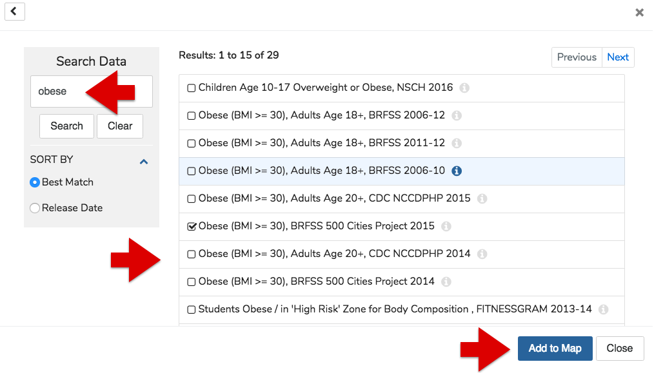

1. For the area data, select “Label” in the Map Layers section. Select “Tract” in the drop down Data Geog menu.

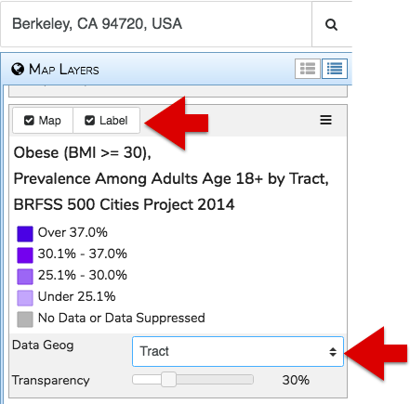

1. In the Map Layers, drag your point data above the area data. The order of data listed in this section will be the order displayed on your map. 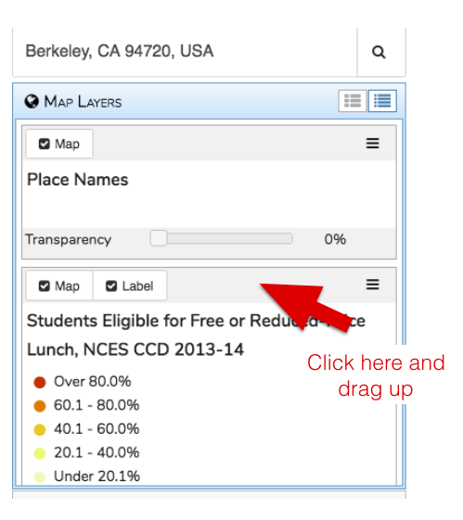

Your map should look something like this (with your own assigned data combination and zip code):

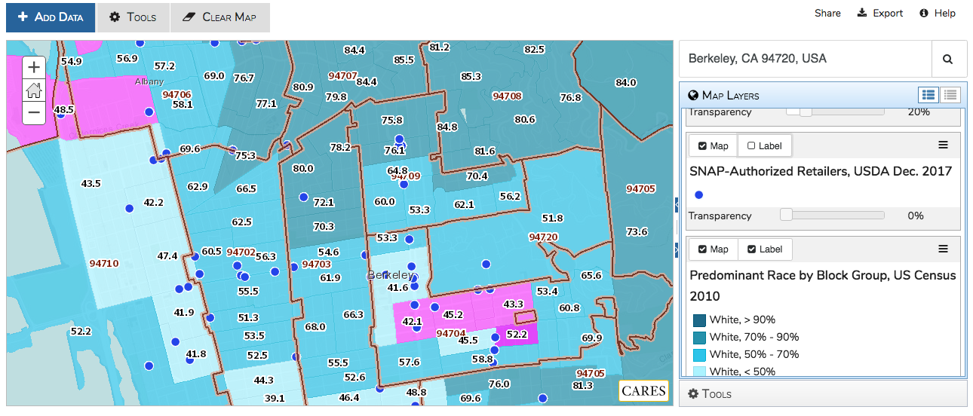

1. Click **Export** on the top right hand side and save map with title format: *First and Last Name, PH150E, Zipcode & Datasets (your data combination)*. Select “Map & Legend, Landscape (11x8.5in)” for Export Layout, PDF Document, and resize map to fit page. Then Export.

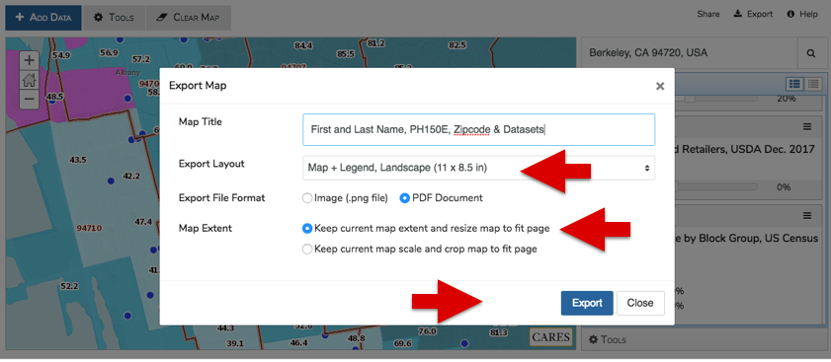

1. Answer questions **11-12** on the HW4 assignment worksheet

**HW #4 Part 3**

**Field Visit & Observing Community Assets**

You will need to visit the same ZIP Code you were assigned for the data and mapping exercise. **Students are encouraged to go in pairs or groups, though each student must submit their own assignment.** In this assignment, you will do a brief field observation to identify some community assets in this place. Too often in community health we focus on needs assessments, which can start from a deficit perspective. The deficit perspective often implies that communities always lack the resources to be healthy. An asset-based approach to community health starts by asking ‘what might be working well here,’ ‘how can we build-upon and lift-up what works’ and ‘what place-based assets enhance health in this neighborhood?’

**BEFORE YOU VISIT YOUR ZIP CODE:**

**Visit the web site: Station-to-Station**

Visit <http://media.journalism.berkeley.edu/projects/2014/20140320_bart/>

“Station to Station” website created by former Professor Bill Satariano and past students from PH150E. Explore the website and data, and watch the videos on your assigned ZIP Code used in Homework 4.

Visit your assigned ZIP Code BART station.

1. Richmond station - 94801
2. 12th Street Oakland station - 94612
3. Fruitvale station – 94601

1. Make a plan to visit your assigned BART station. Some useful tools are the [BART mobile quick planner](http://m.bart.gov/schedules/quickplanner)

Downtown Berkeley → Richmond: via Richmond line

Fare: Clipper card: $2.00, BART blue ticket: $2.50

Downtown Berkeley → 12th Street Oakland City Center: via Daly City line, or Warm Springs / South Fremont line

Fare: Clipper card: $2.00, BART blue ticket: $2.50

Downtown Berkeley → Fruitvale

Fare: Clipper card: $2.35, BART blue ticket: $2.85

*AC Transit is “free” (unlimited use in included in tuition fees) for UC Berkeley students with your AC Transit Student Easy Pass/Clipper card. Visit <https://pt.berkeley.edu/transportation-options/public-transportation-passes-and-info/ac-transit-student-classpass>

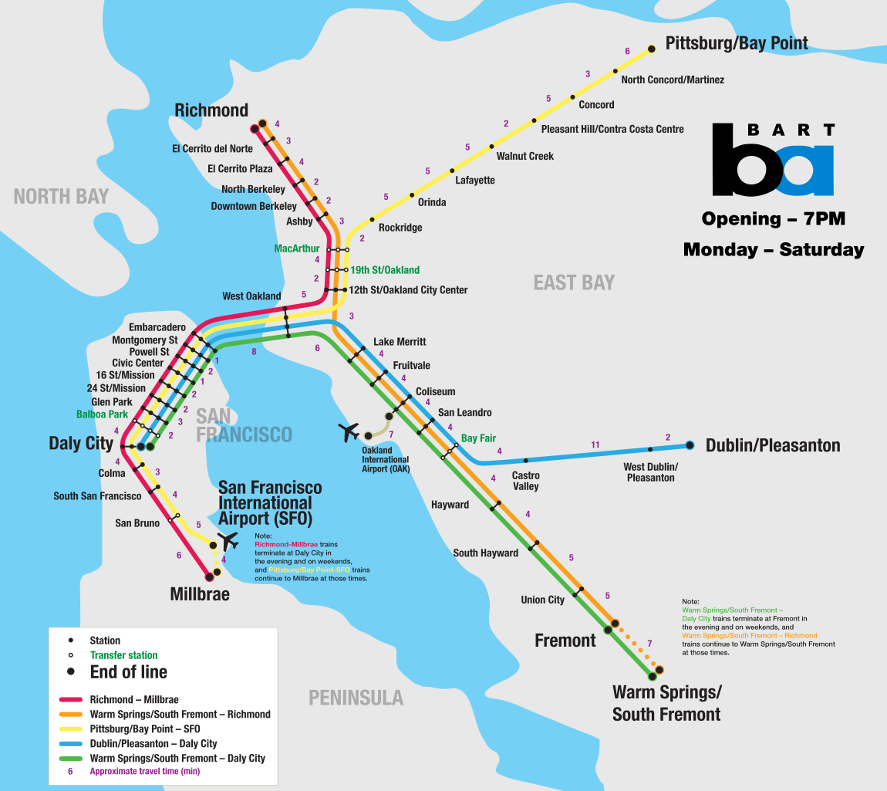

Here are maps around the BART stations:

1. Richmond station – area to explore

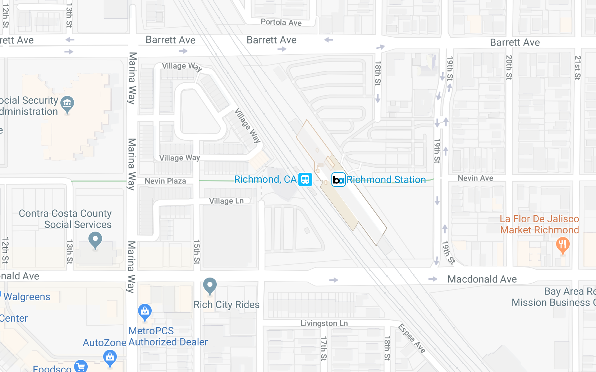

1. 12th Street Oakland station – Frank Ogawa Plaza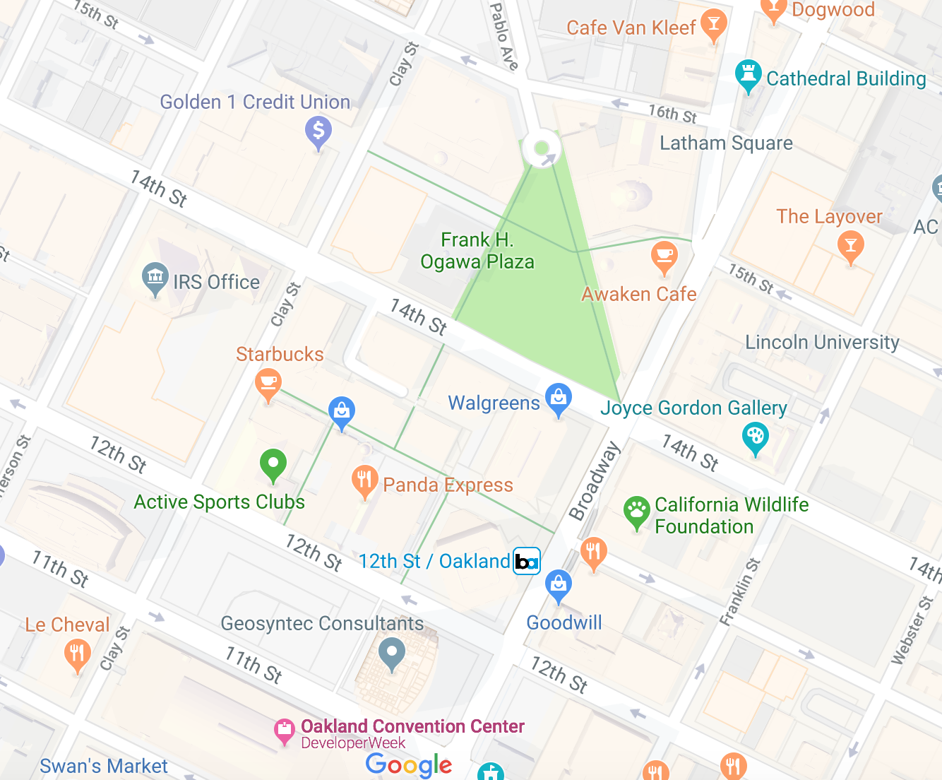
2. Fruitvale station – Transit Village

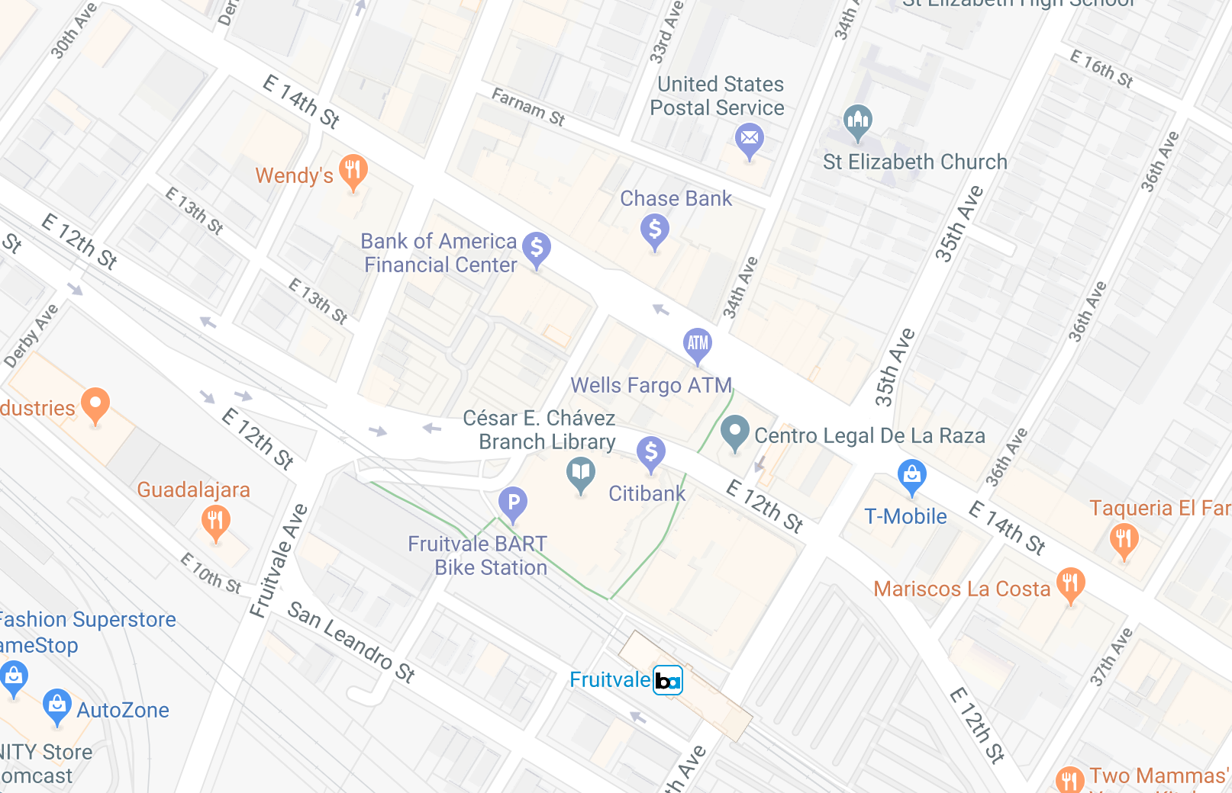

*Answer the following questions in the worksheet document, but be sure to track the necessary information while at your BART station.*

Homework – Required Questions

1. **Describe a public transportation asset you see from the BART station that isn’t BART (i.e., bus stops, bike share, flex car sites, vanpool).**

**2. Describe one food asset you see around the BART station area**. **If there aren’t any, please note this.**

3. **Spend a few minutes observing people coming and going. Describe one activity that you see around the BART station where people are interacting (i.e., street food vendor, someone playing music, adults helping kids cross the street, etc.).**

**4. Take a picture of one asset you see. Attach the picture either in this document or as a separate file to bcourses. In a few sentences below, answer the following: What did you take a picture of? What asset does this represent to you? What else does your picture communicate about this place?**

**Be sure to pload your exported map and completed worksheet under the assignments tab in Bcourses!**